Appendices

Annex I. Interview Questions:
- What do Ethio telecom managers experience in terms of the growth in Importance and awareness of service marketing performance measurement, and how did these changes come about?

- What systems, tools, processes, methods or techniques does Ethio telecom use to monitor, measure and report on it service marketing performance?

- How advanced is Ethio telecom conceptually and practically in terms of measuring service marketing performance?

- What challenges do Ethio telecom faces in measuring its Service marketing performance?

- How do you see customers’ value creation in the delivery of ET’s services to its customers while maximizing its profit?

- How can Service Quality Provision of ET be evaluated from Customers’ Point Of View?

Annex II. Questionnaire for Customers (Service Quality Dimensions)

- Strongly disagree =1
- Disagree =2
- Neutral =3
- Agree =4
- Strongly agree =5

Sr. No. | Dimensions | No. Respondents who Responded |  |  |  |  | Total
 |  | Strongly disagree | Disagree | Neutral/Intermediate | Agree | Strongly agree
1 | Responsiveness:
 | Employees are attentive
 | Employees are helpful
 | Employee is prompt
 | Employees understand my need
 | Employee is courteous
2 | Reliability of Telecom product/service
 | Call received exactly what I need first and always
 | call is served error free
 | Call is instant and no interruption
3 | Physical appearance and Design
 | Telecom infrastructure is easily accessible
 | Telecom infrastructure is clean
 | Telecom product/service has all the desired products services
 | Adequate services are available(like pre paid cards)
 | Design of the product(fixed line, wireless, mobile sim card), has quality attributes
 | There is full network coverage
 | There is full internet connectivity
 | The product/service tariff is cheap
4 | Empathy
 | The service provision by Ethio telecom is caring and individualized attention is provided
 | Corporate customers are given due care because of their volume of transaction with the enterprise
5 | Assurance
 | Employees of the enterprise have adequate knowledge on how to serve their customers
6 | Satisfaction
 | Over all, I am satisfied with Ethio telecoms product/services
 | Considering, the type of service they provide today, the quality is excellent

Annex III. Ethio telecom Company Profile

Company Mission and Values

As a continuation of the last five-year plan and after concentrating its efforts on education, health and agriculture, the Ethiopian government has decided to focus on the improvement of telecommunication services, considering them as a key lever in the development of Ethiopia.
Ethio telecom is born from this ambition of supporting the steady growth of our country. We wish to implement state-of-the-art processes, to develop reliable network infrastructures and to provide the best quality of services to our Customers. This is our mission; this is what drives all our actions.
To ensure that ethio telecom runs parallel with top telecom operators, the Ethiopian government has reached an agreement with France Telecom, one of the world’s leader telecommunication companies. This agreement will help ethio telecom to improve its management capability through the transfer of world-renowned know-hows and skills.
While meeting international standards, we remain faithful to our values:
- We commit to understand, meet and exceed the telecommunications needs and expectations our country at large and of customers in particular
- We respect our customers and recognize that their revenues allow ethio telecom to operate
- We recognize that the company employees are the most valuable asset and want to create an efficient corporate management environment that allows them to develop and grow
- We will commit to high-level job performance, customer service quality, organizational excellence and continuous improvement in all areas
- We will stay motivated and encouraged to meet all the challenges that we will face
- We will make every effort to achieve a superior financial return
- We uphold ethical standards, being honest in all assignments
- We will hold ourselves accountable to all our stakeholders
Company Objectives
[In line with its ambitious mission, Ethio Telecom has ambitious goals:
- Being a customer centric company
- Offering the best quality of services
- Meeting world-class standards
- Building a financially sound company
To reach these goals, all our divisions will focus on:
- Developing and enhancing network and information system
- Ensuring easy access and coverage to the whole population
- Creating a strong brand
- Developing human resources management
- Implementing control standard processes
- Improving financial, sourcing and facilities processes

Company Strategy
Ethio telecom will achieve its goal of both providing a reliable network and of improving Customer Services through a range of different levers that are part of its development strategy.
Ethio telecom will develop and enhance the information system. This will help to decrease the delay for provision, sales and activation as well as to provide more reliable information to Customers.
Ethio telecom will develop a world-class human resources management. This will help to improve employees’ ability to meet the needs and expectations of Customers.
Ethio telecom will implement control standard processes. This will help to increase reactivity and to faster Customer access to services.
Ethio Telecom will develop better sourcing & facilities processes. This will help to faster delivery and repair and will offer more transparency to Customers.

Company Management Chart

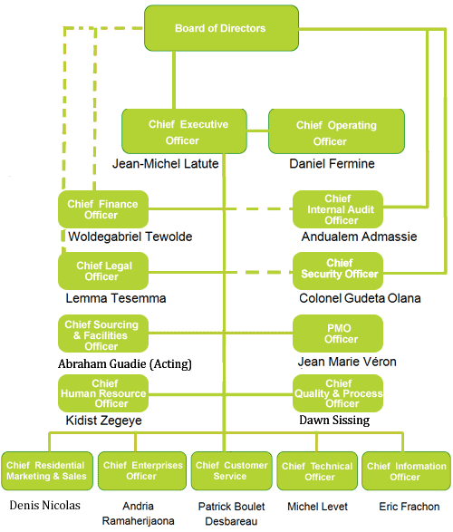

Annex IV - Company Brand

