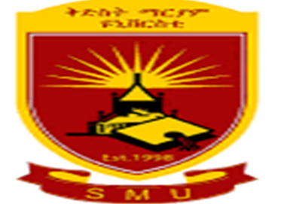

Application of Data Mining with Knowledge Based System for Diagnosis and Treatment of Cattle Diseases: The case of International Livestock Research Institute (ILRI) Animal Health Center Addis Ababa

By

Zerihun Fantahun Wele

July 2021

Application of Data Mining with Knowledge Based System for Diagnosis and Treatment of Cattle Diseases: The case of international livestock research institute (ILRI) animal health center
By
Zerihun Fantahun Wele
to

The Faculty of Informatics

of

St. Mary’s University

In Partial Fulfillment of the Requirements
for the Degree of Master of Science

in
Computer Science

July, 2021

ACCEPTANCE
Application of Data Mining with Knowledge Based System for Diagnosis and Treatment of Cattle Diseases: The case of international livestock research institute (ILRI) animal health center
By
Zerihun Fantahun Wele

Accepted by the Faculty of Informatics, St. Mary’s University, in partial fulfillment of the requirements for the degree of Master of Science in Computer Science

Thesis Examination Committee:

________________________________________________________
Internal Examiner
Dr. Alemebante Mulu

_________________________________________________________
External Examiner
Dr. Minale Ashagrie

__________________________________________________________
Dean, Faculty of Informatics
Dr. Alemebante Mulu

July 2020

